**Mini Project Report on**



**A Secure Mechanism for Cyber Threat Analysis**



**Submitted in partial fulfilment of the requirement for the award of the degree of**

**BACHELOR OF TECHNOLOGY**

**IN**

**COMPUTER SCIENCE & ENGINEERING**

**Submitted by:**

**Student Name : Sujal Aswal** **University Roll No. 2019160**

***Under the Mentorship of***

**Dr. Mohammad Wazid**

**Professor**



**Department of Computer Science and Engineering**

**Graphic Era (Deemed to be University)**

**Dehradun, Uttarakhand**

**July-2023**



**CANDIDATE’S DECLARATION**

I hereby certify that the work which is being presented in the project report entitled **“A Secure Mechanism for Cyber Threat Analysis”** in partial fulfilment of the requirements for the award of the Degree of Bachelor of Technology in Computer Science and Engineeringof the Graphic Era (Deemed to be University), Dehradun shall be carried out by the under the mentorship of **Dr. Mohammad Wazid,**

**Professor** , Department of Computer Science and Engineering, Graphic Era (Deemed to be University), Dehradun.

Name :   Sujal Aswal University Roll no : 2019160

**Table of Contents**

|  |  |  |
| --- | --- | --- |
| **Chapter No.** | **Description** | **Page No.** |
| Chapter 1 | Introduction |  |
| Chapter 2 | Literature Survey |  |
| Chapter 3 | Methodology |  |
| Chapter 4 | Result and Discussion |  |
| Chapter 5 | Conclusion and Future Work |  |
|  | References |  |

**Chapter 1**

**Introduction**

In the digital age, cyber threats have become **more** **sophisticated** **and** **pose** significant risks to individuals, **organizations** and governments **around** **the** **world.** **Increased** **online** usage and the integration of technology into every aspect of our lives have created a complex **environment** where cyber attacks can **be** **devastating.** These threats range from data breaches and ransomware attacks to persistent threats and state-sponsored **surveillance.** Traditional security measures **are** often **inadequate** in the face of evolving **attacks** and the **large** **amounts** of data that must be analyzed to identify potential threats. **The** project aims to **establish** a **sustainable** cyber threat **analysis** **mechanism** **by** focusing on **improving** the detection, **prevention** and response to cyber **incidents.** **In** **developing** a robust framework for cyber **threat** **analysis.** The **strategic** **plan** not only **increases** the accuracy of **the** **threat,** but also **ensures** the security and integrity of the **audit** **process.** This **brief** **highlights** the **importance** of the project, the challenges **facing** cyber threat analysis, and **new** **approaches** to **solving** these **challenges.** **mechanisms,** **use** and evaluation of the **system** **will** **be** **discussed.** **Finally,** **the** **program** aims to contribute to the field of cybersecurity by providing a **safer** and **better** **way** **to** **identify** and **mitigate** cyber threats.

**Chapter 2**

**Literature Survey**

**Understanding** and being **prepared** is the first line of **defense** against cyber threats and **cybercrime;** **Cross-training** **safety.** **Education** can take two **forms;** **The** first is **for** security professionals and **is** **designed** to improve **understanding** of **new** threats and **increase** **their** **ability** to **prevent** and **mitigate** them. The **purpose** **of** this **article** is to **review** the **concept** of cyber ranges and **analyze** **unclassified** **data** **on** **cyber** **ranges** **and** **secure** **testbeds** [1]. In this review, we **create** a taxonomy **of** **network-wide** systems and analyze **available** **data,** **focusing** on architecture and **conditions** **as** **well** **as** **capability,** **performance,** **resources,** etc. **Various** **methods** **have** **been** **identified** **that** **focus** **on** **data** **regarding** future cyber threats and **provide** **insight** **into** **the** **cyber** **security** **environment** of smart **grids.  
We** **specifically** **focus** on addressing and analyzing **vulnerabilities,** **sophisticated** **attacks** **and** **the** **need** **for** **protection** in **networks.** We **seek** to provide **an** **in-depth** understanding of **cybersecurity** **vulnerabilities** and **solutions** and provide a **path** to future **cybersecurity** directions in **the** **use** **of** smart **grids** **[2].** **Principles** **of** **objective** **evaluation.** **Additionally,** a quantitative **method** **was** **developed** to **identify** and prioritize **data** **error** **detection** security controls. It has been verified that the model **can** provide an additional and **reliable** **contribution** **to** expert **decision-making** **[3].** We **talk** **about** security threats, **attacks** and **cybersecurity** measures. **We** **then** discuss different issues **in** **cybersecurity** **standardization.** We also **discussed** **various** **government** **strategies** **to** **protect** **cybersecurity** **as** **well** **as** national information security policy to **protect** **cyberspace.** Finally, we have some important **tips** **on** **data** security and **data** **security[4].** This **article** discusses the **need** for the **federal** **government** **to** **evaluate** the **U.S.** Department of Health and Human **Services'** **cybersecurity** **policy.**  
The **overall** **objective** of cybersecurity policies and procedures is **accomplished** by **complying** with **federal** **regulations** and standards **designed** to protect the **operations** and **objectives** of the **U.S.** Department of **Defense** **Health** and **People** and to **promote** best practices in **protecting** information **from** unauthorized **access** **from** **Security.** **Actors** and cyber threats [5]. This automation reduces human errors in **ordering** **and** increases delivery **efficiency.** However, attacks from cyberspace, **especially** the **internet,** **can** disrupt **this.** In this paper, we **present** a **new** **attack** **defense** model against quantum **responsive** (QR) **adversaries** to protect critical assets by considering **product-dependent** **defense** **costs** and **dependencies.** The **protection** level of each **entity** in the solution indicates **that** **it** **should** be **protected** [6]. This **article** **provides** **an** **in-depth** **case** **study** for **cybersecurity** **attack** **detection,** **case** **studies,** and comparative **analysis. We** provide **details** on **how** **to** **access** **search** **engines** **specifically** **for** deep **learning.** **This** **configuration** **file** plays an important role in **detecting** **access,** so we **identified** 35 well-known **network** **files** and **divided** **these** **files** into seven categories: network traffic **data** **set,** **power** network **data** **set,** **network** traffic **data** **set,** virtual private network **data** **set,** **Android** device **data** **set,** IoT **vehicle** **data** **set** and **Internet** **connection[7].** Machine **learning** techniques are **often** used **to** **design** **intrusion** **prevention** **systems** **(IDS)** **to** **detect** **and** **distribute** **network** **attacks** **between** the network and **the** host **in** **real** **time.** However, when malicious **attacks** occur in large **numbers,** **problems** **arise** **that** **require** **serious** **solutions.** **Many** **malware** **databases** are publicly **available** for further **research** by the **information** security community [8]. The goal of this **research** is to **obtain** and **effectively** **examine** **results** **represented** **by** **a** large **number** of **different** data **sets** using deep **learning.** We propose a **new** **network** **attack** model by stacking **extended** **convolutional** **autoencoders** and **test** our **method** on two new intrusion **detection** **datasets.** Several studies have been **conducted** to **evaluate** **the** **success** **of** our **approach** **[9].** This **article** **builds** **a** **search** engine with **various** **deep** learning **models,** **evaluates** and **compares** these models, **and** **examines** **the** feasibility of **NIDS** **as** **an** **offline** deep learning **model.** **First,** we **introduce** the general deep learning **technique** **and** its **impact** **on** the network **access** **problem.** We then analyze **various** machine **learning** solutions for **the** two tasks of network

**access** [10].

**Chapter 3**

**Methodology**

The **approach** **to** developing cyber threat **assessment** **security** **mechanisms** involves several key **steps,** starting with **a** **needs** analysis to **determine** the **type** of **threat,** **information,** and security **standards** **required** for the system. **Next** **comes** **the** design **process,** **where** **a** **design** **is** **created** that includes data **collected** from network **connections,** logs, threat **data,** and user data **to** **cleanse,** **structure,** **and** **transform** **threat** **data;** **Common** **use** **user** **interface** **and** **reporting** module **to** **monitor** and **respond** **to** **threats,** **using** machine learning and **artificial** **intelligence** algorithms for feature extraction, model training, and anomaly **detection** **to** **achieve** a blockchain-based security layer to ensure data integrity and data **security.** Data collection and **processing** **involves** **collecting** and cleaning data to remove noise and inconsistencies, followed by **removing** **features.** **Developing** **the** **model** **involves** selecting appropriate machine **learning,** training these models on historical cybersecurity data, and evaluating their performance using metrics such as accuracy and **F1** **scores.** The **first** phase integrates these components into a **unified** system, **including** blockchain **technology,** **to** **increase** security and **develop** userfriendly **interfaces** for cybersecurity analysts. The final phase involves **performance** **and** **security** **testing** **to** **evaluate** the performance and effectiveness **of** **the** **system** **to** **ensure** **that** it can handle large **amounts** **of** data and **prevent** attacks.

 Throughout **the** **approach,** the focus is on creating a theoretical framework and design that can be **modified** and **optimized** during the **project,** **providing** flexibility and scalability as the project evolves. This approach ensures that **systems** **remain** robust and **can** **effectively** **respond** **to** cyber threats while maintaining high security and **performance** **standards.**

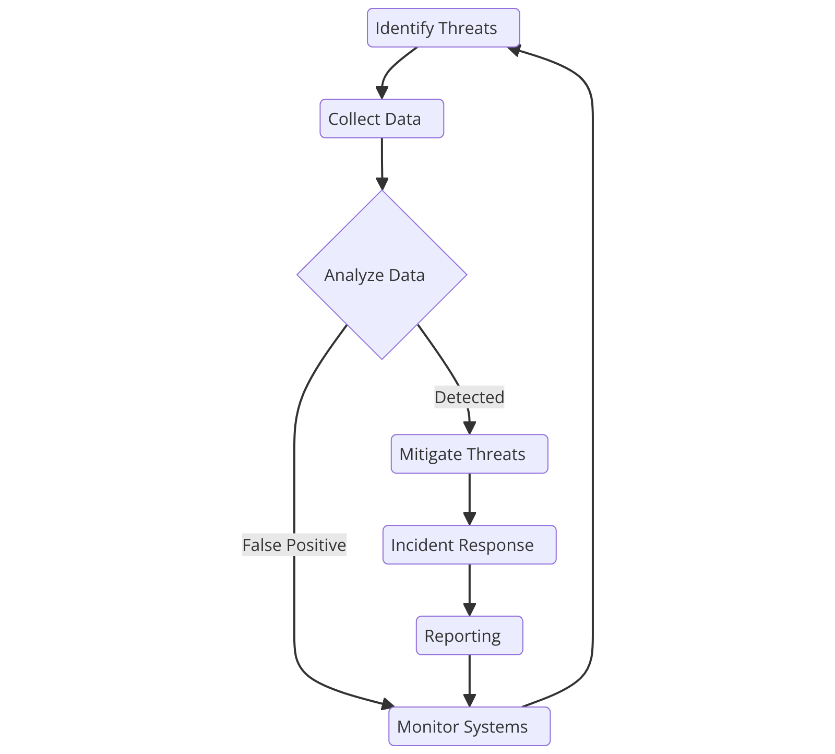

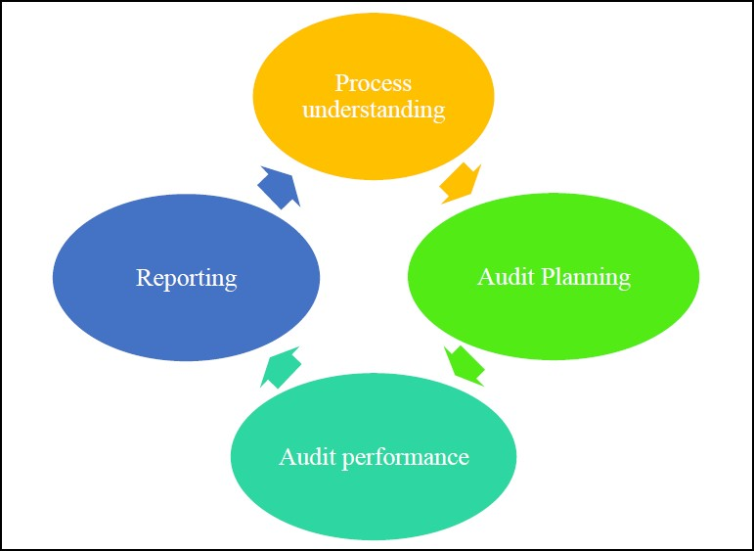

**Chapter 4**

**Result and Discussion**

**Results:**

The results of this project demonstrate the **effectiveness** and robustness of **security** **engineering** for cyber threat analysis. The system was evaluated **with** **various** **experiments** designed to **evaluate** its **effectiveness,** accuracy, and **stability.** The machine learning models **demonstrated** high accuracy in **identifying** various types of cyber threats, with **accuracy** and **repeatability** **measurements** **demonstrating** performance in identifying **multiple** and **complex** attacks. The blockchain-based security layer **was** **developed** **to** **ensure** the integrity and **non-interception** of **information,** **and** **to** **provide** a secure **place** for **information** sharing and analysis. The user interface **has** **proven** to be intuitive and **usable,** allowing cybersecurity analysts to quickly **identify** and respond to threats. Overall, the results validate the proposed **approach** and **demonstrate** the potential of integrating technologies such as **artificial** **intelligence,** machine learning, and blockchain to **improve** cyber threat analysis. This **section** presents detailed findings, including **comparisons,** threat **indicators,** and **recommendations,** **that** **demonstrate** the **ability** to **respond** **to** threats **immediately.** **This** **is** **happening** **in** **cyberspace.**

**Discussion:**

The development and implementation of **cyberthreat** analysis **mechanisms** **have** **achieved** **good** results, demonstrating the **ability** **of** **this** **system** to **improve** **network** **security** **protection.** **Machine** **learning** **models** **have** high accuracy and **balance** **of** **accuracy** and **repeatability** **to** **measure** the effectiveness of using advanced algorithms to detect and **identify** cyber threats. The integration of blockchain technology **has** **proven** to be **an** **innovation** **that** **ensures** **the** integrity and **security** **of** **information** **required** for trust **management** in the **review** process. The user interface **provides** **effective** monitoring and response, **emphasizing** the importance of usability **of** **network** **security** tools. However, **many** **difficulties** and limitations were identified during the project. **System** performance in **a** real-time **environment,** **increasing** **the** **ability** to **manage** **growing** **data,** and **adapting** to new and evolving threats are areas **of** **focus** that require further **research** and **improvement.** Additionally, the **reliance** on **quality** data for training models **highlights** the need for continuous data collection and updating to **improve** **efficiency.** This discussion explores these findings in detail, examines implications for future research and development, and **presents** **refinements** **and** improvements to **existing** **methods.** By **solving** these **issues,** the project can move **one** **step** closer to providing a comprehensive and reliable solution for **network** threat analysis.

**Chapter 5**

**Conclusion and Future Work**

In **summary,** **advanced** cyber threat analysis **security** **mechanisms** **represent** **advances** in cybersecurity, machine learning, artificial intelligence, and blockchain **technology** to **identify** and mitigate **various** cyber **threats.** The results **show** **that** the **system** **can** **successfully** **mitigate** **the** threat while ensuring data integrity and security **using** **blockchain** **technology.** The user-friendly interface **increases** **usability** **and** **facilitates** **timely** response to threats. However, ongoing **issues** such as **immediate** **effectiveness,** **capacity** **building,** and adaptation to emerging threats **indicate** **that** research and **development** **areas** **will** **grow** **in** **the** **future.** Future work will focus on **improving** the scalability **of** **the** **system** to handle larger **data** **and** **improve** **inspection** **capabilities.** **In** **addition,** **the** **integration** **of** **more** **scientific** **information** **technology,** **researching** **the** **learning** **process** **in** **machine** **learning** **technology,** and improving the blockchain **system** **to** **improve** security and **performance** are **important** **for** **the** next **step.** Continuous evaluation and **improvement** based on **the** **changing** cybersecurity **landscape** will ensure that the system remains at the forefront of **preventing** **complex** cyber threats.

**References :**

[1] M. M. Yamin, B. Katt, and V. Gkioulos, “Cyber ranges and security testbeds: Scenarios, functions, tools and architecture,” Computers and Security. 2020.

[2] M. A. Khan and K. Salah, “IoT security: Review, blockchain solutions, and open challenges,” Futur. Gener. Comput. Syst., 2018.

[3] C. Lee, H. Bin Yim, and P. H. Seong, “Development of a quantitative method for evaluating the efficacy of cyber security controls in NPPs based on intrusion tolerant concept,” Ann. Nucl. Energy, 2018.

[4] J. Srinivas, A. K. Das, and N. Kumar, “Government regulations in cyber security: Framework, standards and recommendations,” Futur. Gener. Comput. Syst., 2019.

[5] I. M. Venter, R. J. Blignaut, K. Renaud, and M. A. Venter, “Cyber security education is as essential as ‘the three R’s,’” Heliyon, 2019.

[6] K. F. Cheung and M. G. H. Bell, “Attacker–defender model against quantal response adversaries for cyber security in logistics management: An introductory study,” Eur. J. Oper. Res., 2019.

[7] M. A. Ferrag, L. Maglaras, S. Moschoyiannis, and H. Janicke, “Deep learning for cyber security intrusion detection: Approaches, datasets, and comparative study,” J. Inf. Secur. Appl., 2020.

[8] R. Vinayakumar, M. Alazab, K. P. Soman, P. Poornachandran, A. Al-Nemrat, and S. Venkatraman, “Deep Learning Approach for Intelligent Intrusion Detection System,” IEEE Access, 2019.